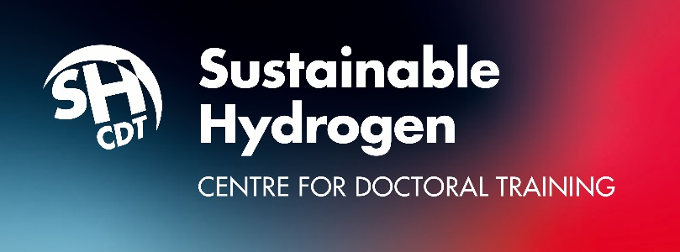

Sustainable Hydrogen Centre for Doctoral Training
Application Form Questions

The online Application Form (on our website at www.sustainablehydrogen-cdt.ac.uk/applications/apply.aspx ) to apply to study at the Sustainable Hydrogen CDT must be completed in one sitting and then submitted. Half-completed forms, unfortunately, cannot be saved for applicants to return to online and complete later.

A list of all Application Form questions (with word limits were applicable) is included below, to enable you to draft your answers in advance, before opening an online Application Form.

Application Form Questions
Your details
- First name/ last name
- Email address
- Residency status (UK based or International)
- Please upload your CV (selection process is anonymised, CVs are not used as part of the application process).

Research project
- You are asked to choose 3 PhD projects from the list of project titles in the CDT’s current Projects Booklet.
Project titles appear on the form in dropdown menus and you are asked to rank projects by First, Second and Third Choice. You must choose 3 projects from at least 2 different CDT partner universities (Nottingham, Loughborough, Birmingham, Ulster).
- If you are submitting your own project proposal, you must still choose at least 2 other projects from the choices given in the dropdown menus.

Option – Enter your own proposal
- Enter your own project’s title.
- Give a description of the project.
- Choose the preferred university at which to study the project.

Knowledge
- Please tell us what qualifications you have. Include final grades for all completed degrees (Bachelors and/or Masters), course titles and name of university where you studied.
- If currently studying for a degree (not yet completed) please include your current module grades.
(Please NOTE: The CDT’s course requirements are a 1st or 2:1 undergraduate degree, or a Distinction in a postgraduate Masters degree, in a relevant topic; or equivalent experience if coming from industry (answer has a 100 word limit).

- International students only – please tell us what English Language qualification you have (100 word limit).

- Please show - using an example from your studies or work - that you have knowledge in a specific area relevant to your preferred SusHy CDT project, and the ability to develop that knowledge as part of your doctorate (100 word limit).

Skills
- Please show us - using an example from your life, studies or work - that you have the skills to be an effective researcher, e.g: problem solving, critical analysis, creative thinking, resourcefulness, etc (100 word limit).

Importance of diversity
- Given that the current challenges in energy generation and use are global, cross cultural and multi-disciplinary - and also that there are a number of technologies which unintentionally fail sections of the population - offer your evaluation of how working with people from different backgrounds (e.g. gender, ethnicity, class, cultural, etc.) could help an innovation team reach more effective solutions (200 word limit).

Motivation
- Please tell us how an aspect of your personal identity has influenced your passion for your chosen discipline and a passion to contribute to change in the energy sector (this could be personal values, social background, gender, ethnicity, or any other aspect of your identity) (100 word limit).

Equal Opportunities monitoring
- Age
- Gender
- Disability (if applicable).
- Ethnic Origin.
- Sexual orientation (if you wish to say).

SUBMIT FORM

Thank you

